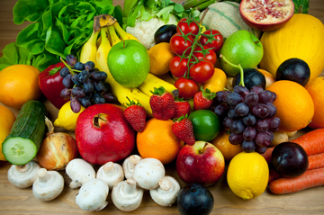

Calorie 2 Grocery

ASE Project Increment#1

Project Group #12

Sravani Punyamurthula

Vaishnavi Aienampudi

Leela Naga Devi Gajula

Vinaya Podduturi

**Introduction**

Diet plays a major role in leading a healthy life style. Due to busy schedules, it has become difficult to plan for a healthy and nutritious diet. Diet is nothing but a pattern of eating food. It is important to concentrate on diet to stay healthy and happy. Proper diet reduces the risk of many diseases.

Obesity and weight gain are the most common problems today. Irregular and improper diet leads to obesity. So it is important to plan our meal to include necessary ingredients and avoid over consumption of food. Calorie information gives the energy content of food. Hence, Calorie intake is a good measure to check on weight gain.

Another common problem in day to day life is grocery management. Now-a-days, it is common to forget the groceries available at home. Not keeping track of the expiry dates leads to wastage of food. There are many web apps/Android apps which give the calorie information for different varieties of food items. Also, there are apps which aid in grocery management. But there is no single application that handles both the functionalities. An integrated app is much more useful to the user because it helps in proper planning of the meal based on calories per serving and groceries available.

**Objective**

“Calorie2grocery” is an android application that helps its users to plan for a proper meal to maintain healthy life style. Firstly, it provides the calorie count of a recipe. The app has a browser which allows the user to import a recipe and get a list of ingredients. The app then displays the calorie count for each ingredient in the recipe. Each user has his/her own specifications and preferences for recipes. Hence the app provides its users with an option to edit the ingredient list. Users can add or remove ingredients and can get the total calorie count of that recipe. The calorie count helps its users to take healthy choices about their meal. Secondly, it automatically generates a shopping list so that the user does not miss anything that he needs to buy. It provides us the flexibility to log the groceries available at our home. Our app will generate alert notifications about the expiry dates of groceries which in turn helps in reducing the wastage of food. Based on the recipe chosen it, prepares the list of ingredients to buy in order to prepare the recipe. Thus the app functions as a unified meal planner which takes care of grocery management as well as provide calorie information to plan for a healthy meal. Our app also displays a list of nearby grocery stores, so that the user can easily go and purchase products.

**Framework Specification:**

Our framework consists of three stages namely GUI, API, Database and a parser. Database handles the storage of data like the user profile information, grocery list, saved recipes etc. GUI editor is developed as mobile application. The GUI connects to the database/API and gets the required data. The data fetched from the API’s is parsed by the parser and displayed in the user interface.

**Increment#1:**

We have built the GUI for login, registration and home pages as part of Increment1. The home page will be modified throughout the project as we add functions to our application. We have established the database connection from the GUI. As part of increment1, we have added functionality to store the user profile information in the database. API is used to display the current location of the user and to display the nearby grocery stores. We have added authentication logic which enables the GUI to communicate with the database and verify the user.

**System Architecture:**

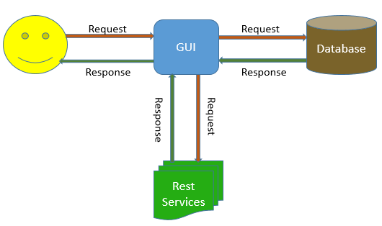

**Application Specifications:**

|  |  |
| --- | --- |
|  | **Tools** |
| Platform | Android 4.0.3 |
| UML Diagrams | Microsoft Visio |
| Languages | Java, C# , ASP.Net |
| Database | SQL Lite |
| Planning | ScrumDo |
| Version Control System | GIT |
| Rest Services | Google Places API |

**Implementation of User Interface:**

We have developed four layouts as part of UI implementation.

1. Registration page
2. Login page
3. Welcome/Home page
4. Layout for viewing the google maps

If the user is a new user, then he has to register to use the app. After registering, the app redirects to the login page where the user can login to use the features of this app. When the user logs in successfully, he can perform the following operations:

* He can visualize his current location using google maps.
* He can search the list of nearby grocery stores.

**Design of Mobile Client Interface:**

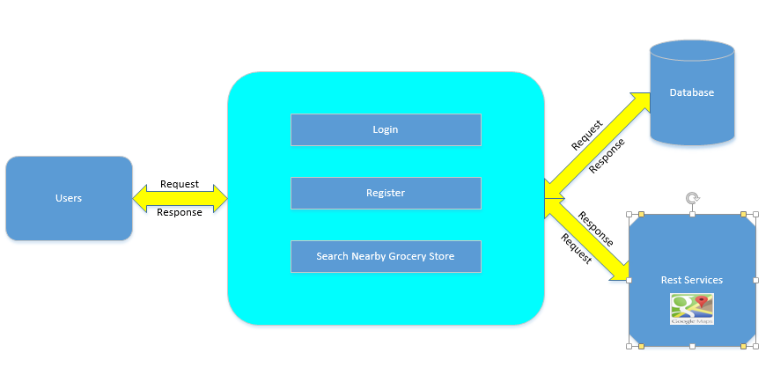

GUI

**Class Diagram:**

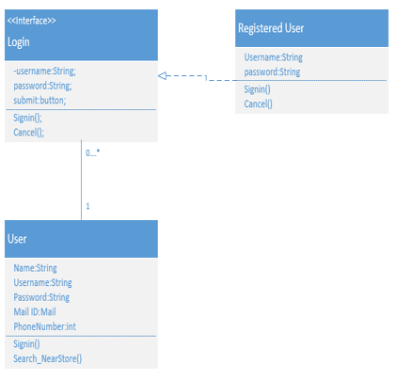

**Sequence Diagram:**

In our sequence diagram, there are five components. When the user is an unregistered or a new user, the GUI asks the user to register with his details. The details of all the users are stored in the data base. If the user is already a registered user, the GUI asks the user to login. When the registered user enters his login credentials, the GUI checks the details from the database, and if he is a valid user, it redirects to the home page. Once, he goes to home page, the user has the options to view the current location and get the list of nearby grocery stores. When the user wishes to search for a nearby grocery store, the GUI communicates with the API and returns the results to the GUI where the user can visualize. The GUI component is displayed as Admin in the following diagram.

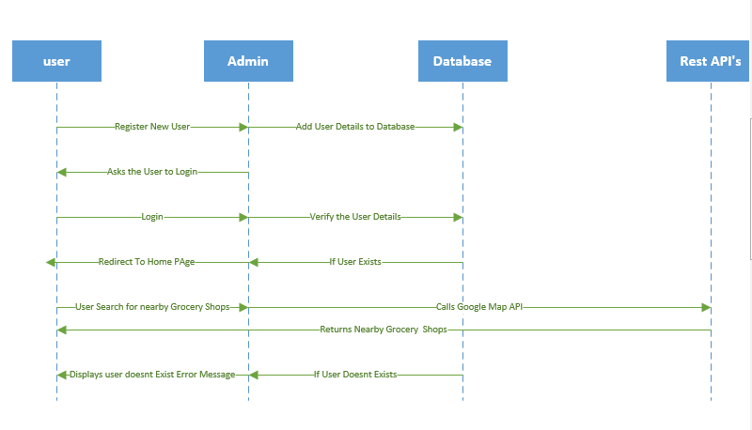

Here users interact with the GUI to login or register. When the user logs in, the GUI checks the data from the database and displays Welcome Screen. When the user clicks to Search a nearby grocery store, the GUI interacts with the Rest service API to get the data and displays it on the google map.

**Screen Shots of the UI:**

1. **Login Page:**

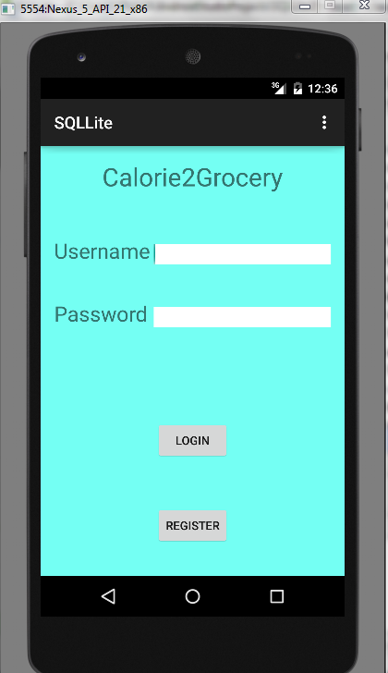

The above image shows the login page for our android application “Calorie2grocery”. The user interface provides the users with two options, Login for already registered users and Register button for new or unregistered users. If the user is already a registered user, he has to provide his username and password to use this application. The below screen shot shows how a login page with the username ‘Vignesh’. When he clicks on login button the login page transitions into home page.

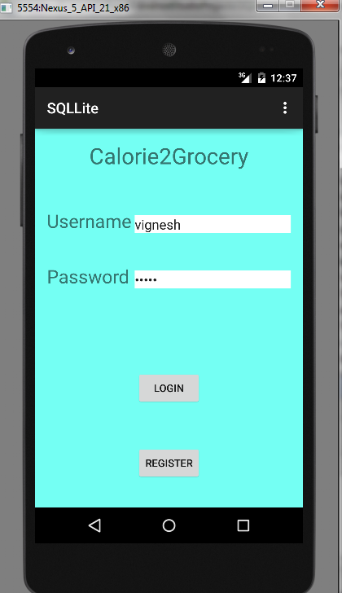

1. **Home Page:**

The below screenshot displays how a homepage looks like in our app “Calorie2grocery”. When the user logs into the system, home screen is displayed. Our home screen consists of three buttons. This page will be modified throughout the application development to add more features to the app.

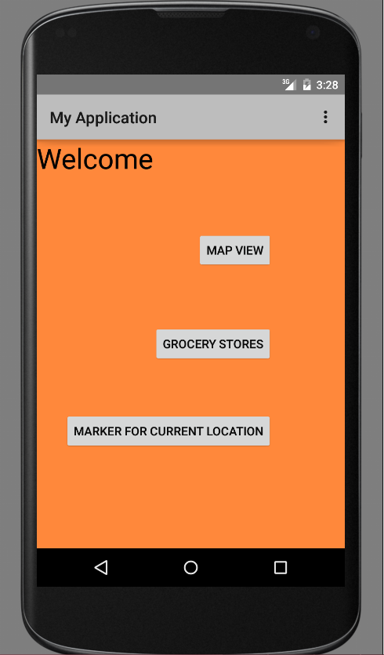

1. **Registration page for new or unregistered users.**

If the user is a new or unregistered user, the GUI asks him to register. When the user clicks on registration page, the GUI redirects it to a registration page. The below screen shot shows how a registration page looks like.

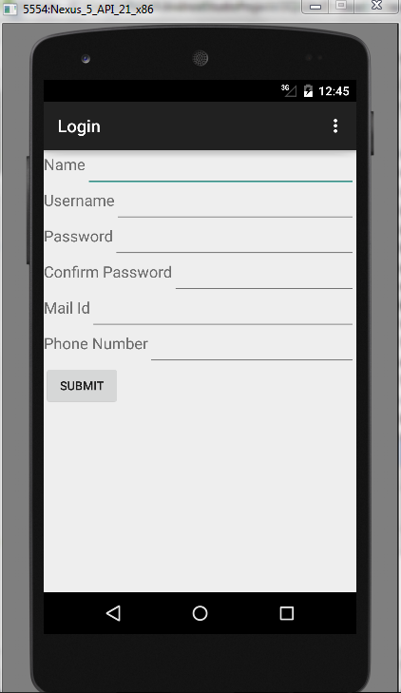

The registration page, asks the user to register by entering his details. The below screenshot shows while entering the details.

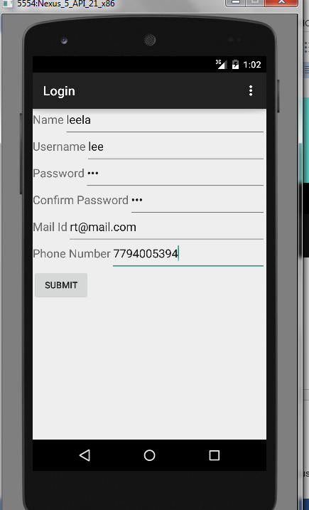

The registration page provides a button to submit his/her details. When the user submits his details, the details are stored in the database. After submitting his details, the user interface redirects to another page which gives him a confirmation that he has registered successfully and provides the user with a link to the Login page.

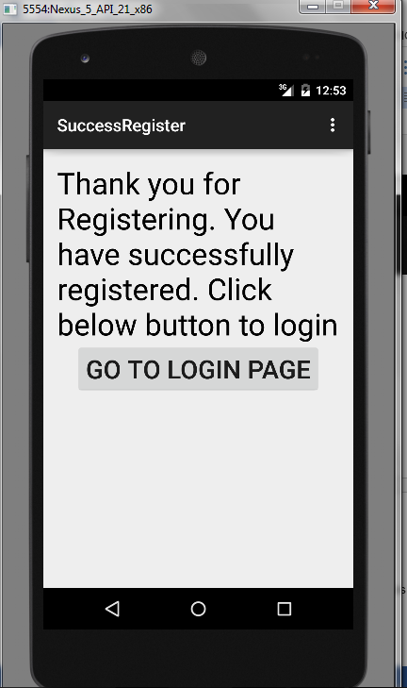

This is the screenshot for the page displayed, after registering successfully. It provides a button to GO TO LOGIN PAGE. When the user clicks this he can go to login page.

**Implementation of existing API:**

Our welcome page has three buttons related to location services. The grocery store button displays the nearby grocery stores using the google places API. We have started implementing the API by first fetching the information to display the current location. The button “Marker for current location” implements this logic. Then we have implemented the logic for opening the google maps. The “Map View” button is used for executing this logic.

For using google API’s, we have installed google play services from android SDK manager. We have created an application in google console to get the API key and API secret key which need to be configured in the manifest file of the android application.

**Screen Shots for implementation of API:**

**Grocery Stores -** When the user clicks on grocery stores, it transitions to another page. The below screen shot displays the screen how it looks like when we click grocery store.

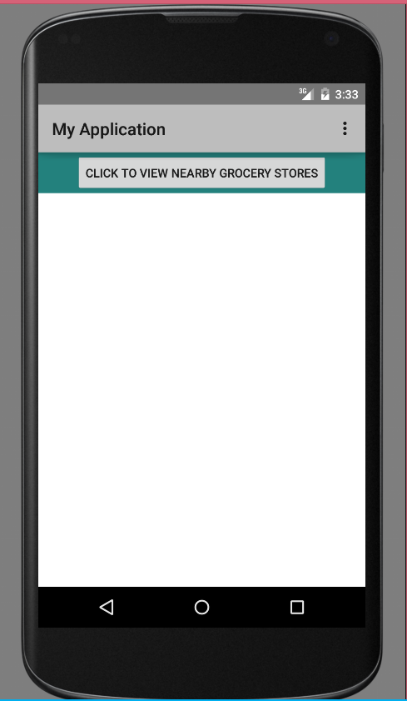

The above page is displayed when the user clicks on grocery stores. This page has a button which redirects to google maps on clicking it. When the user clicks the button, it displays a google maps page with markers at nearby grocery store.

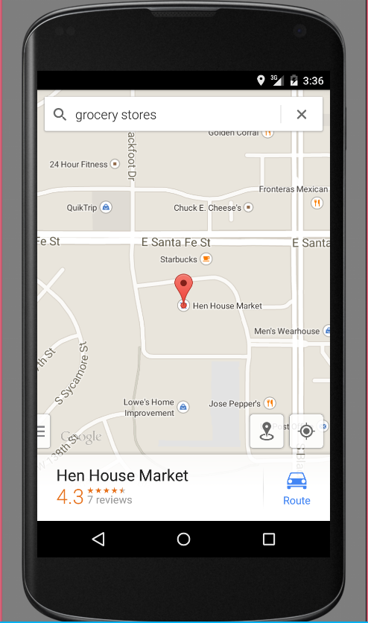

The above screenshot displays the maps with a marker on a nearby grocery store.

**Marker Button:**

When the user clicks on marker button, it redirects to a google maps page which has a button named city. The below screenshot shows the page that loads on clicking the marker button.

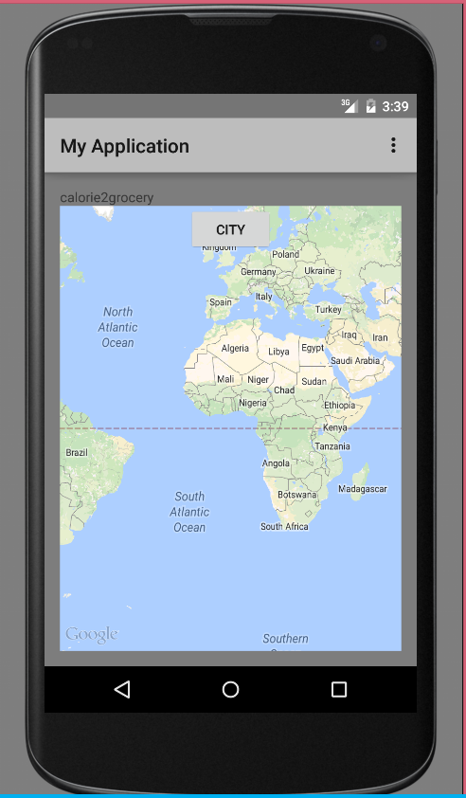

When the user clicks on CITY button, the user interface displays a marker at the users’ current location with a tag “You’re here!!!”.

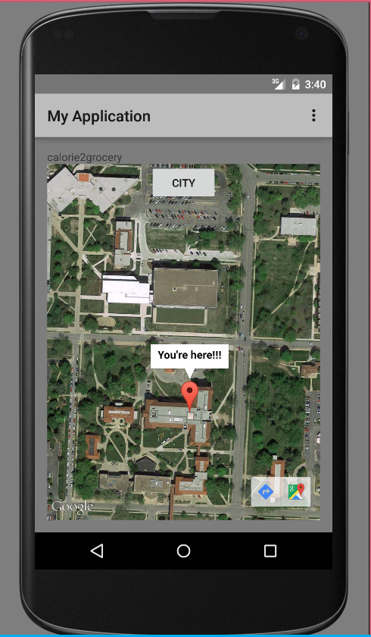

**Database Implementation:**

We have established the connection to the SQLLite database from the android application. To establish the connection, we have installed the SQLLite plugin. We have created the register table in the database. The information that the user inputs from the registration page will be loaded into the database. During login, the username and password entered by the user will be authenticated using the values present in this table.

The below screen shot shows the image of how the values are stored in the database when the user registers. We have created sample users as part of testing.

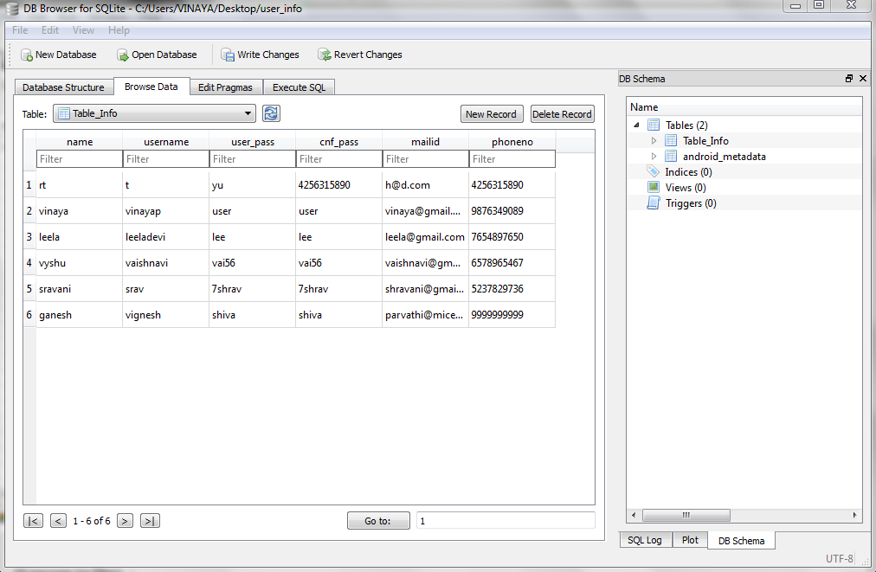

**Design of Test Cases:**

We have divided the test cases into two parts:

1. UI Testing
2. Data validation

**UI Testing:**

As part of UI testing, we have verified that the transitions from page to page happen as expected. Following are the manual test cases for transition of the UI.

|  |  |  |  |
| --- | --- | --- | --- |
| **Page** | **Button** | **Expected** | **Actual** |
| Login | Register | Registration page | Registration page |
| Login | Login (with correct username & password) | Welcome Page | Welcome Page |
| Login | Login (with incorrect credentials) | Error Message, ask to re-enter credentials | Error Message, ask to re-enter credentials |
| Registration | Submit | Thank you page to show successful registration | Thank you page to show successful registration |
| Registration Success Page | Click to Login | Login page | Login page |
| Welcome Page | Grocery Stores | Grocery layout | Grocery layout |
| Grocery | Click to view nearby grocery stores | Google maps | Google maps |
| Welcome Page | Marker for current location | Google maps | Google maps |

**Data Validation Tests:**

For Increment#1, we have two test cases for data validation.

1. We have verified that the data entered in the register table matches with the user input.
2. **User authentication:**

Positive test case: Upon entering the correct user credentials, the authentication should succeed and the GUI need to transition to the Welcome page.

Negative test case: If we enter incorrect username and password, the app should throw an error message.

**ScrumDo :**

We have used Scrumdo to track the progress of the project. The project development is divided into four increments. All the functions and development tasks are written as user stories.

**Link:**

<https://www.scrumdo.com/organization/umkc240/dashboard>

Following are the screen shots of the scrum board for all the increments:

**Increment#1**

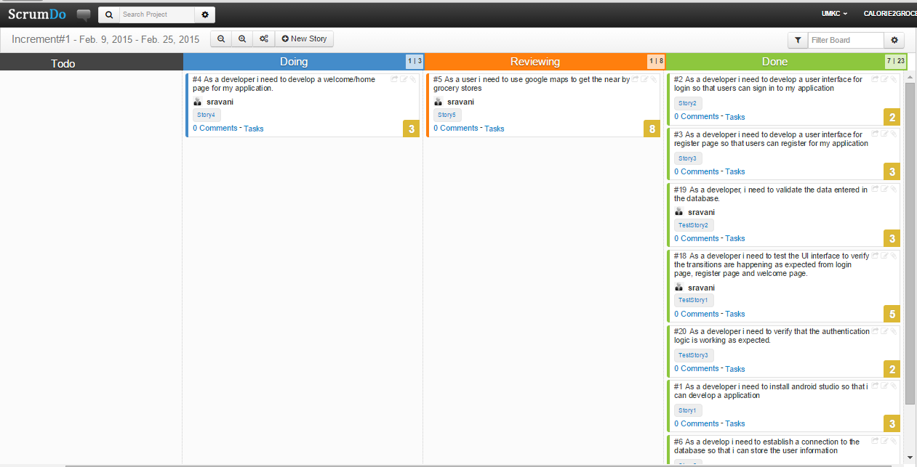

**Increment#2:**

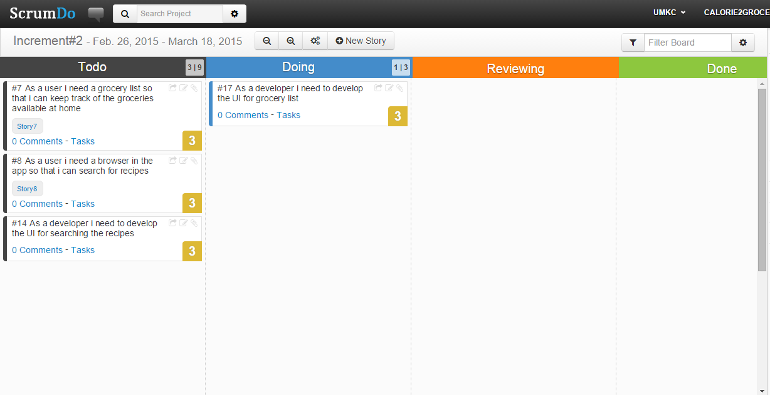

**Increment#3:**

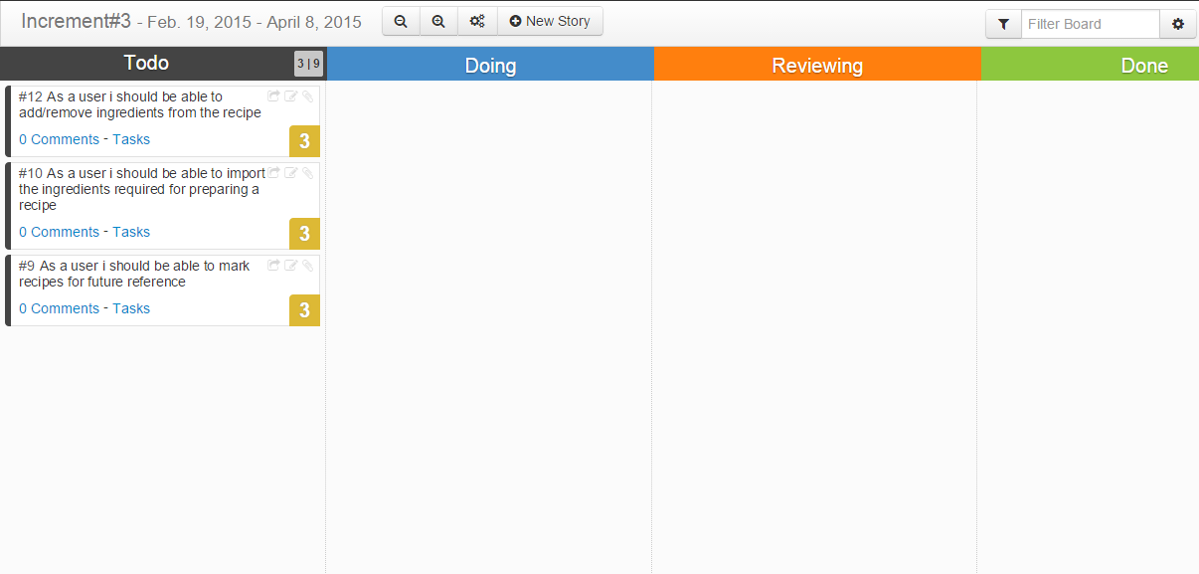

**Increment#4:**

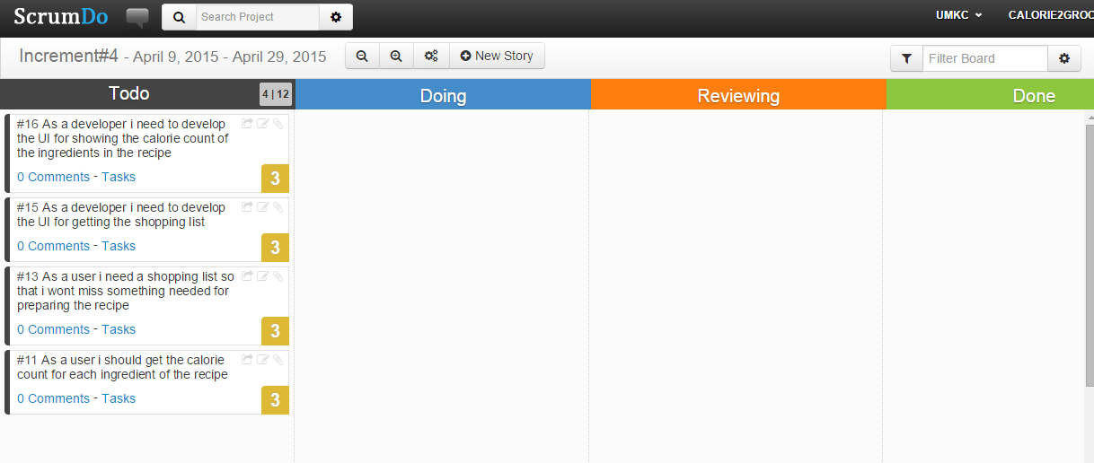

**Implementation Status Report:**

**Work Completed:**

1. **GUI**

Description:

Implementation of login & Registration pages along with database connection. UI implementation of these pages include page transition.

Responsibility:Vinaya , Leela

Time taken: 8 Hours

Contribution:

Database Connectivity: Vinaya (40%) , Leela (30%)

Division of tasks:

Vinaya : Creating the UI for login page and developing the logic for authentication.

Leela: Creating the UI for registration page and developing the logic to load the user input into database.

Testing: Leela(10%) Sravani(10%) Vaishnavi (10%)

Testing includes validation of data and ensuring that the page transitions are performed correctly.

1. **API & Welcome Page**

Description:

Implementation of google places api to get the nearby grocery stores. Creation of welcome page/home page that has all the features of the app.

Responsibility:Sravani , Vaishnavi

Time taken: 10 Hours

Contribution:

Database Connectivity: Sravani (40%) , Vaishnavi (30%)

Division of tasks:

Sravani : Creating the UI for welcome page and developing the logic for fetching data from google places api.

Vaishnavi: Implemented the marker logic to show the current location.

Testing: Vaishnavi(10%) Vinaya(10%) Leela (10%)

**Issues/Concerns:**

The android studio is very slow. Hence we had to invest more time than normally required for developing applications. Also there is less support online for android studio compared to eclipse for developing android applications.